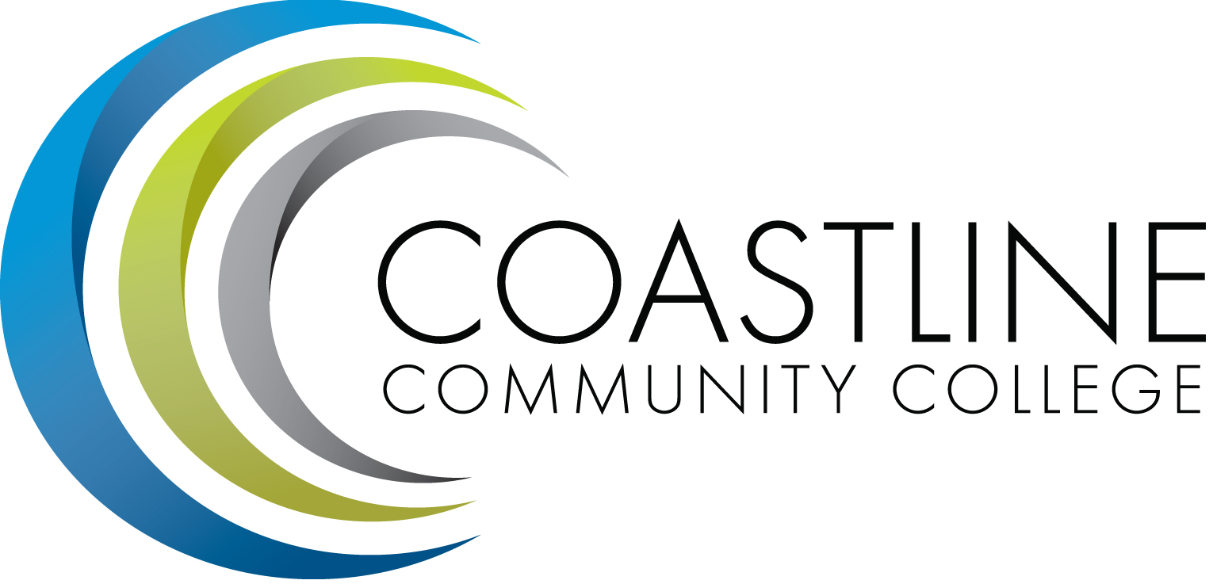

College Professional Development & Leadership Committee Agenda
3/06/2018, 3:00 pm to 5:00 pm
College Center, Distance Learning Conference Room

Committee Mandate: To promote, coordinate, recommend, and support the creation and delivery of professional development and leadership programs that increase the effectiveness of our institution and the satisfaction of our employees.

CALL TO ORDER
  - Welcome
  - Adoption of Agenda
  - Approval of Minutes: 2/06/2018

SPECIAL REPORTS
  - SafeTalk Alertness Training/Veterans-Specific Suicide Prevention Training Summary (March 2, 2018) - Nate

ACTION ITEMS
  - Follow up on Action Items from (12/05/2017):
3.1.1 None

STANDING REPORTS
  - FSC Update – Cheryl
  - Classified Update - Araba
  - Human Resources Update – Renate
  - Flex Update - Ann

DISCUSSION ITEMS
  - Spring Workshop/BBQ – Shelly
  - Summer Institute – Shelly
  - 4C/SD - Shelly
  - Professional Development Program Plan 2017/18 - Shelly

ANNOUNCEMENTS
  - Next Meeting: (April 3, 2018, College Center, Distance Learning Conference Room)

ADJOURNMENT

